1.16: The area is 9.69 ± 0.07 cm², where the extreme values in the piece’s length and width are used to find the uncertainty in the area. The fractional uncertainty in the area is 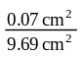 = 0.72%, and the fractional uncertainties in the length and width are 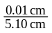 = 0.20% and 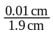 = 0.53%.

